**Smart Home Automation System**

Table of content

1. **About Smart Automation System**

1.1 Abstract

1.2 Introduction

1.3 Objectives

1.4 Swot Analysis

1.5 4w's and 1H

2. **Requirements**

2.1 High level requirements

2.2 Low level requirements

3. **Block Diagram**

3.1 Explanation on blocks

3.2 Sub System and its explanation

4. **Architecture**

4.1 UML Diagram

4.2 Use case Structural Diagram

4.3 Flow Chart

5. **Test Plan and Output**

5.1 High level and Low level

5.2 High level and Low level with images

6**. Advantages and Disadvantages**

7. **Applications**

8. **References**

9. **Demonstration Video**

**Abstract**

* With advancement of technology things are becoming simpler and easier for us.
* Automation plays an increasingly important role in the world economy and in daily experience.
* Automatic systems are being preferred over manual system.

**Introduction**

* Automation is control of the electrical or electronic device within area or remotely.
* The project deals with the safety sensors such as > Earthquake sensor, Temperature sensor, Smoke sensor, Motion Sensor.
* When the sensors detect the input they perform the required operation and alert the person

**Objectives:**

* to improve the quality of life and convenience in the home.
* Different models to be designed for security purpose.

**Swot Analysis**

**Strengths:**

* Efficient and Intelligent energy saving Techniques.
* Safety and Security will be increased.
* Single Protocol.
* Support for Efficient operation.

**Weakness:**

* cost of system may be increased
* Replacement of devices will be difficult
* complex system

**opportunities:**

* Advancement in Technology.
* Infrastructure Management.

**Threats:**

* Targeted Attacks
* Short lifespan of Device
* Data Manipulation
* Identity Theft

**4W's and 1H**

Who???

* This system is used by consumers for automizing their home.

What???

* This is an automated system used for controlling the electrical and electronic devices

When???

* This system can be used whenever there is the need of automation

Where???

* This System can be used in Residential, Commercial and Industrial buildings

How???

* This system is human machine interface which senses the input and Displays the output and alerts the person

**Requirements**

**High Level Requirements:**

|  |  |
| --- | --- |
| RID | DESCRIPTION |
| HLR1 | Home shall be Automated |
| HLR2 | System shall sense the motion |
| HLR3 | System shall sense the smoke |
| HLR4 | System shall sense the environmental changes |
| HLR5 | System shall sense the temperature |

**Low Level Requirements:**

|  |  |
| --- | --- |
| RID | DESCRIPTION |
| LLR1 | led shall be turned on and displayed if Motion sensor (PIR) detects |
| LLR2 | temperature shall be displayed if temperature is sensed |
| LLR3 | vibration value shall be displayed if earthquake sensor detects |
| LLR4 | led shall be turned on if earthquake sensor does not detect |
| LLR5 | Exhaust fan shall be turned on if smoke is detected |

**Block Diagram of Smart Home Automation System**

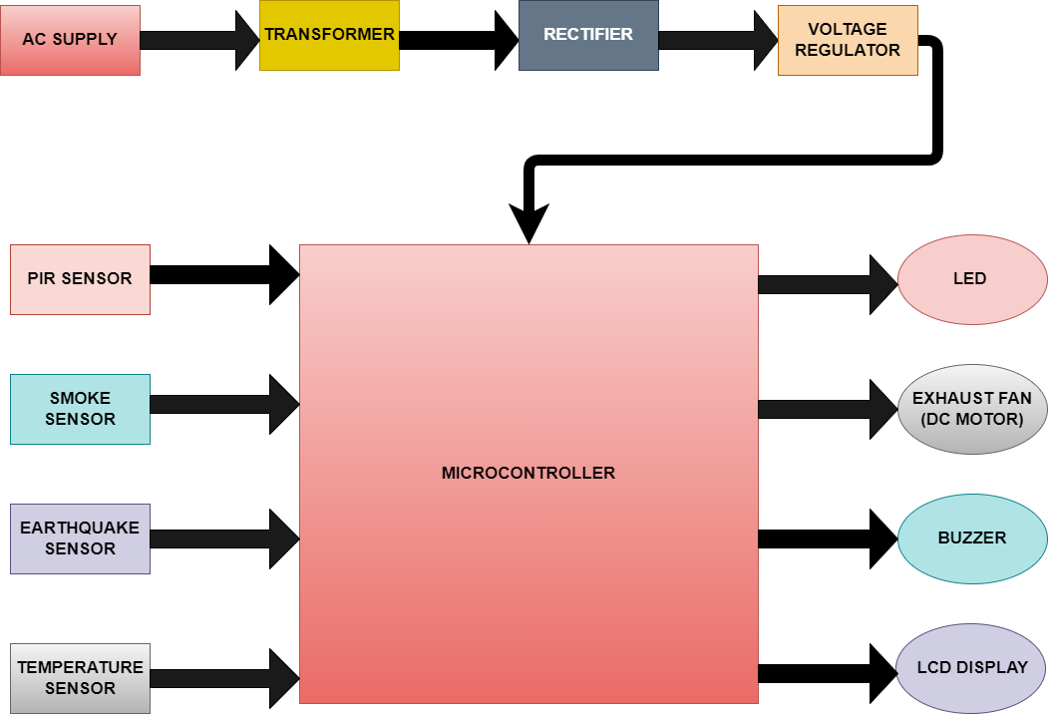

**Microcontroller**

* It is the Heart of the embedded system.
* It does majority of the work starting from taking the data or instructions in, processing it according the program written and finally provide the output to complete the required function.

**PIR Sensor**

* A Passive infrared (PIR) sensor is an electronic device that measures and detects infrared radiation in its surrounding environment.
* In the above project the PIR sensor is used to detect the motion around the surrounding and provide the output

**Smoke Sensor**

* The smoke sensor is used to detect the smoke around the surrounding and perform the necessary actions

**Earthquake Sensor**

* An earthquake is an unavoidable and unpredictable natural phenomenon that often causes damage to lives and property. We cannot fight it but we can stay alert and aware using technology
* In the above Project the earthquake sensor sense the vibration and displays the vibration values and alerts the person.

**Temperature Sensor**

* Temperature sensor is used to detect the temperature around the surroundings and perform its operation.

**Dc Motor (Actuator)**

* The Dc Motor is used as the exhaust fan which turns on when the smoke is detected

**Buzzer**

* an electrical device that makes a buzzing noise and is used for signalling used as an output device

**LCD Display**

* LCD display is used to display the output of the sensor.

**Block Diagram of Subsystem**



**Power Supply**

* In this Power Supply we use Stepdown transformer, Rectifier and the voltage regulator.

**Stepdown Transformer**

* this is used to step down the incoming voltage i.e., 230V to 5V so that the upcoming components are comfortable for operation.

**Rectifier**

* This device is used to convert the incoming 5v Ac to 5V dc (ac to dc converter).

**Voltage Regulator**

* As we Know that the output of the rectifier is a Pulsating dc so voltage regulator is used to make the pulsating dc voltage to constant dc voltage.

**Architecture**

* UML Diagram

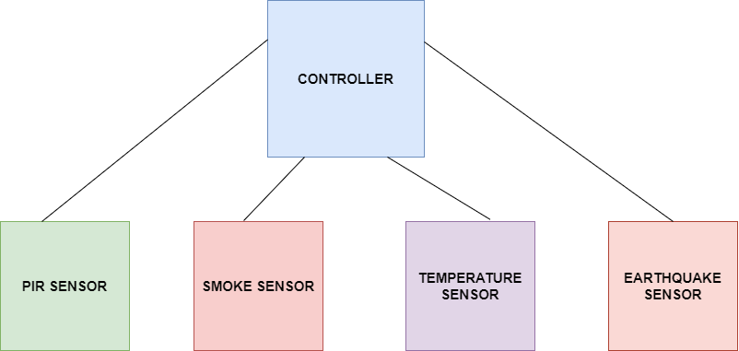

* Use Case Structural Diagram

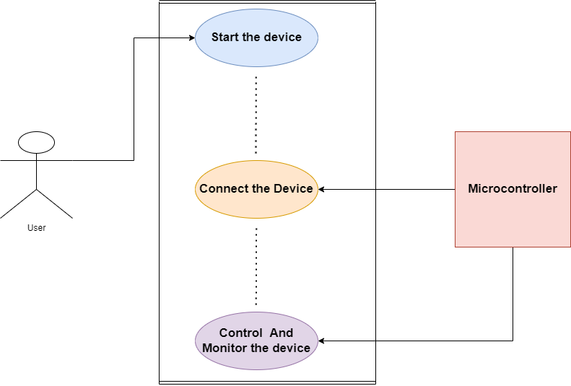

* Flow Chart

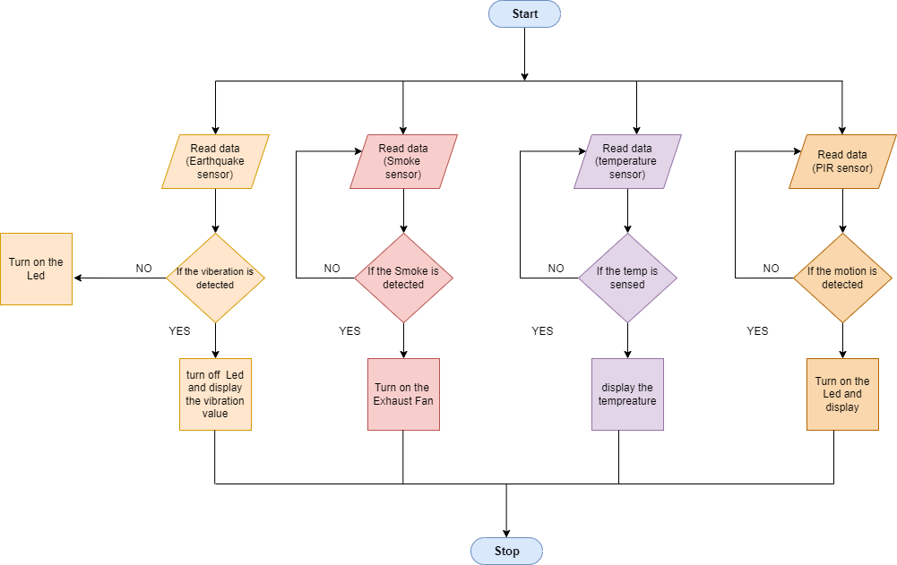

* Simulation

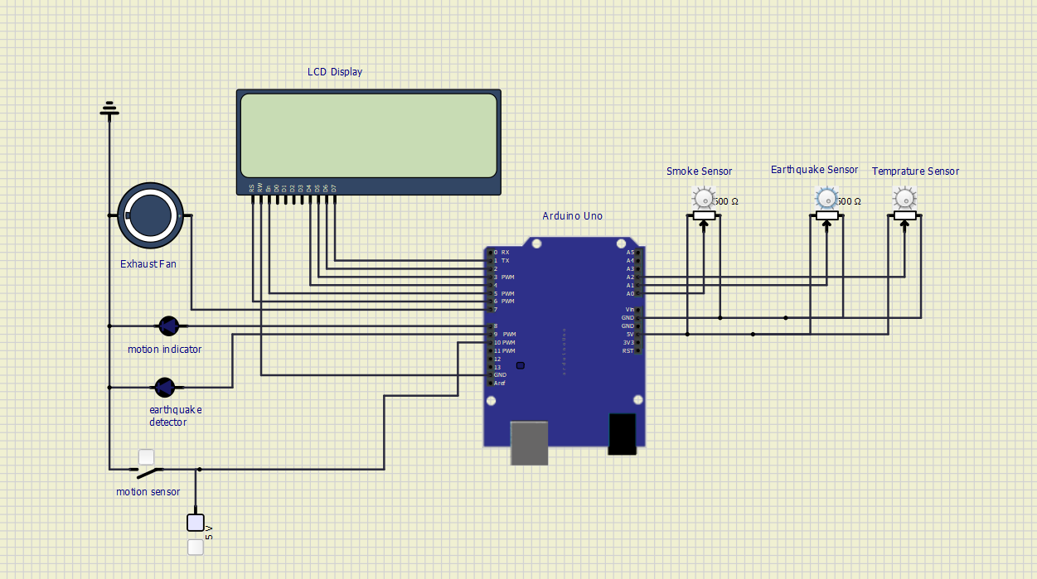

**Test Plan**

**High Level Test:**

|  |  |  |  |  |  |
| --- | --- | --- | --- | --- | --- |
| **Test id** | **Description** | **expected I/p** | **expected o/p** | **Actual o/p** | **pass/fail** |
| HLT1 | Motion Sensor | Sense the Motion | Sensed | Sensed | pass |
| HLT2 | Temperature Sensor | Temperature must be sensed | sensed | sensed | pass |
| HLT3 | Smoke Sensor | Smoke must be sensed | sensed | sensed | pass |
| HLT4 | Earthquake Sensor | Vibration must be sensed | sensed | sensed | pass |

**Low Level Test**

**Low level test on motion sensor (using led)**

|  |  |  |  |  |  |
| --- | --- | --- | --- | --- | --- |
| **Test id** | **Description** | **expected I/p** | **expected o/p** | **Actual o/p** | **pass/fail** |
| LLT1.1 | test for motion sensor | for the simulation PIR sensor is replaced through the switch (when switch is high) | Led ON | Led ON | pass |
| LLT1.2 | test for motion sensor | when switch is Low | Led OFF | Led OFF | pass |

**Low Level Test for Motion Sensor (Using Display)**

|  |  |  |  |  |  |
| --- | --- | --- | --- | --- | --- |
| **Test id** | **Description** | **expected I/p** | **expected o/p** | **Actual o/p** | **pass/fail** |
| LLT1.3 | test for motion sensor | when switch is high | Motion Detected | Motion Detected | pass |
| LLT1.4 | test for motion sensor | when switch is high | Motion not Detected | Motion not Detected | pass |

**Low Level Test for Temperature Sensor (Using Display)**

|  |  |  |  |  |  |
| --- | --- | --- | --- | --- | --- |
| **Test id** | **Description** | **expected I/p** | **expected o/p** | **Actual o/p** | **pass/fail** |
| LLT2.1 | test for Temperature sensor | When Potentiometer is at initial point | temp=0*Celsius | temp=0*Celsius | pass |

|  |  |  |  |  |  |
| --- | --- | --- | --- | --- | --- |
| **Test id** | **Description** | **expected I/p** | **expected o/p** | **Actual o/p** | **pass/fail** |
| LLT2.2 | test for Temperature sensor | When Potentiometer is varied slightly | temp=15*Celsius | temp=15*Celsius | pass |

**Low Level Test for Smoke Sensor**

|  |  |  |  |  |  |
| --- | --- | --- | --- | --- | --- |
| **Test id** | **Description** | **expected I/p** | **expected o/p** | **Actual o/p** | **pass/fail** |
| LLT3.1 | test for Smoke sensor | when smoke value<=threshold value (400) | Exhaust fan OFF | Exhaust fan OFF | pass |
| LLT3.2 | test for Smoke sensor | when smoke value < threshold value (400) | Exhaust fan ON | Exhaust fan ON | pass |

**Low Level Test for Earthquake Sensor (using Led)**

|  |  |  |  |  |  |
| --- | --- | --- | --- | --- | --- |
| **Test id** | **Description** | **expected I/p** | **expected o/p** | **Actual o/p** | **pass/fail** |
| LLT4.1 | test for earthquake sensor | When the Vibration is zero | Led is ON | Led is ON | pass |
| LLT4.2 | test for earthquake sensor | When the Vibration is certain value | Led is OFF | Led is OFF | pass |

**Low Level Test for Earthquake Sensor (using Display)**

|  |  |  |  |  |  |
| --- | --- | --- | --- | --- | --- |
| **Test id** | **Description** | **expected I/p** | **expected o/p** | **Actual o/p** | **pass/fail** |
| LLT4.3 | test for earthquake sensor | When the Vibration is zero | NO Vibration | NO Vibration | pass |
| LLT4.4 | test for earthquake sensor | When the Vibration is certain value | vibration=value of sensor | vibration=value of sensor | pass |

**Tested Output on Motion Sensor**

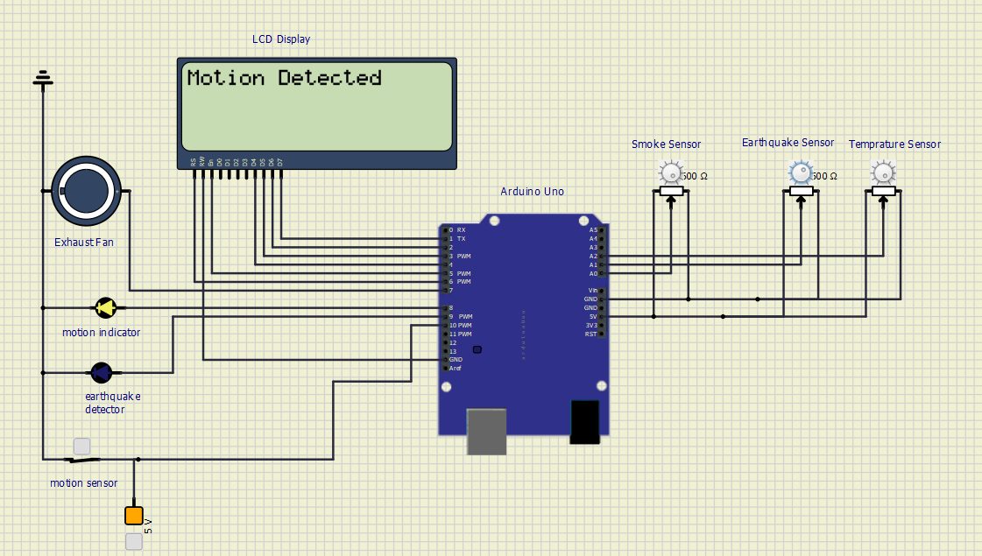

**Tested Output on Temperature Sensor**

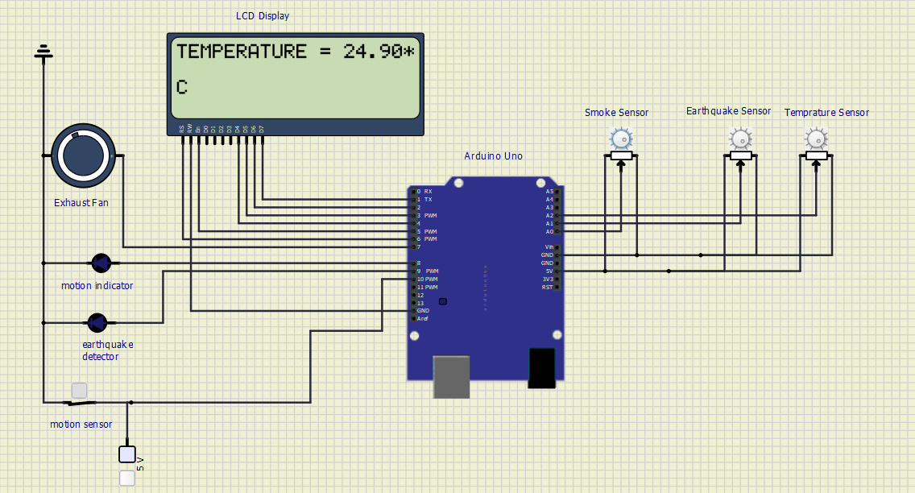

**Tested Output on Earthquake Sensor at value=0** 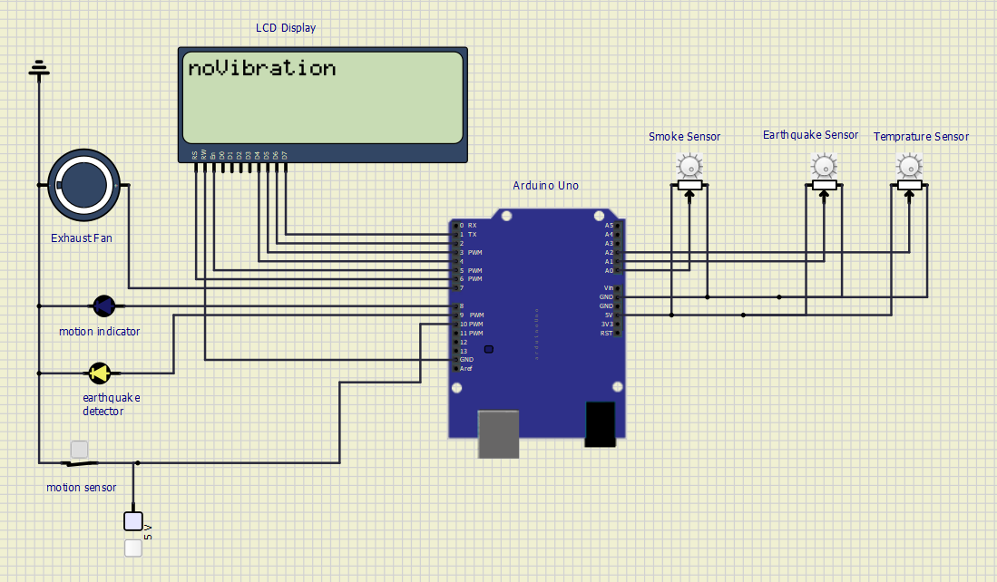

**Tested Output on Earthquake Sensor at certain vibration value**

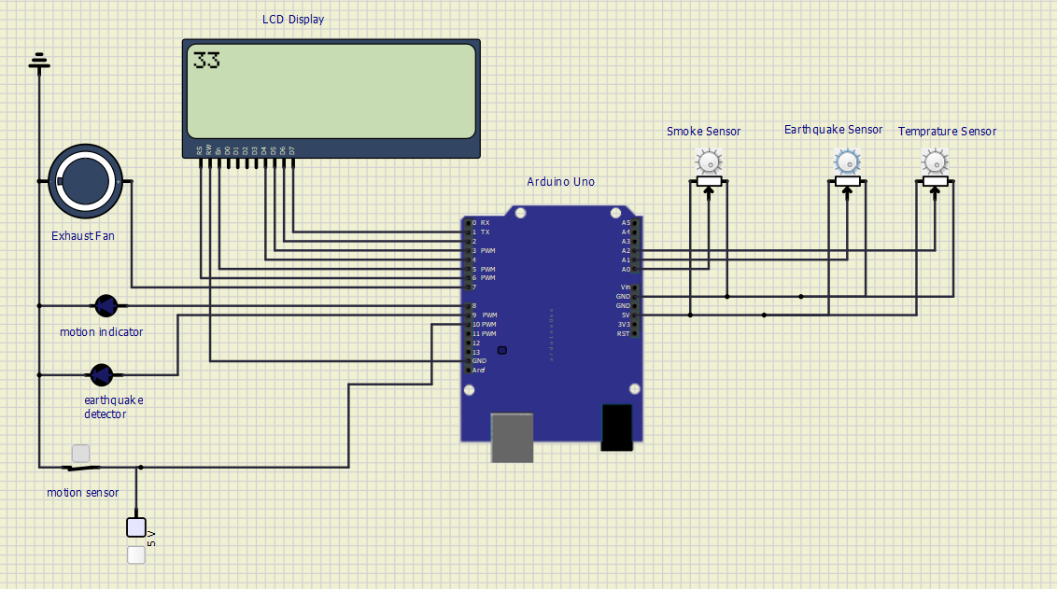

**Tested Output on Smoke Sensor at value=0 (Exhaust fan is OFF)**

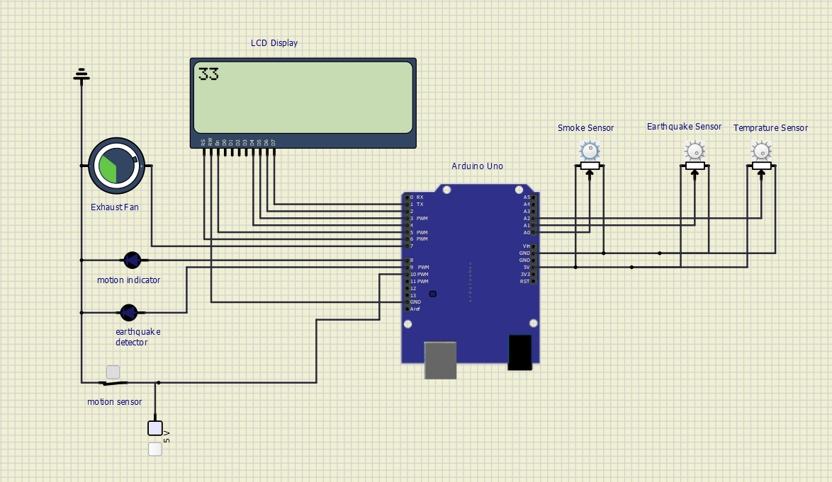

**Advantages And Disadvantages**

**Advantages**

* Easy to use
* Safety and Security is increased
* Provides facility to monitor and control multiple devices

**Disadvantages**

* Installation is costly
* Works only when the object or user is in the range of sensor
* Continuous Power supply is required

**Applications**

* Industries, Residential, Commercial Purpose
* Smart Home Appliances.
* safety and security, etc.

**Reference**

https://www.homemadecircuits.com/pirsensordatasheetpinoutspecificationworking

https://www.signaguard.com/seismicsensor

<https://www.arduino.cc>

**Demonstration Video**

